Spatial and temporal variability in economic availability of residual biomass from timber harvest in west-central Alberta, Canada (1990–2015)

Tables and Figures

Glen W. Armstrong1,✉, Jay A. Anderson2, and Alex W. McPhee2

2021-11-30

1 Department of Renewable Resources, University of Alberta, Edmonton AB T6G 2H1, Canada  
2 Department of Resource Economics and Environmental Sociology, University of Alberta, Edmonton AB T6G 2H1, Canada

✉ Correspondence: [Glen W. Armstrong <[gwa@ualberta.ca](mailto:gwa@ualberta.ca)>](mailto:gwa@ualberta.ca)

# Tables

Table 1: Road speeds based on FPInnovations (km/h).

| Road class | loaded | unloaded | harmonic mean |
| --- | --- | --- | --- |
| primary highways | 85 | 95 | 90 |
| other paved | 77 | 86 | 81 |
| 2-lane gravel | 60 | 67 | 63 |
| 1-lane gravel or dirt | 29 | 25 | 27 |
| no road | 5 | 5 | 5 |

Table 2: Summary statistics.

# Figures

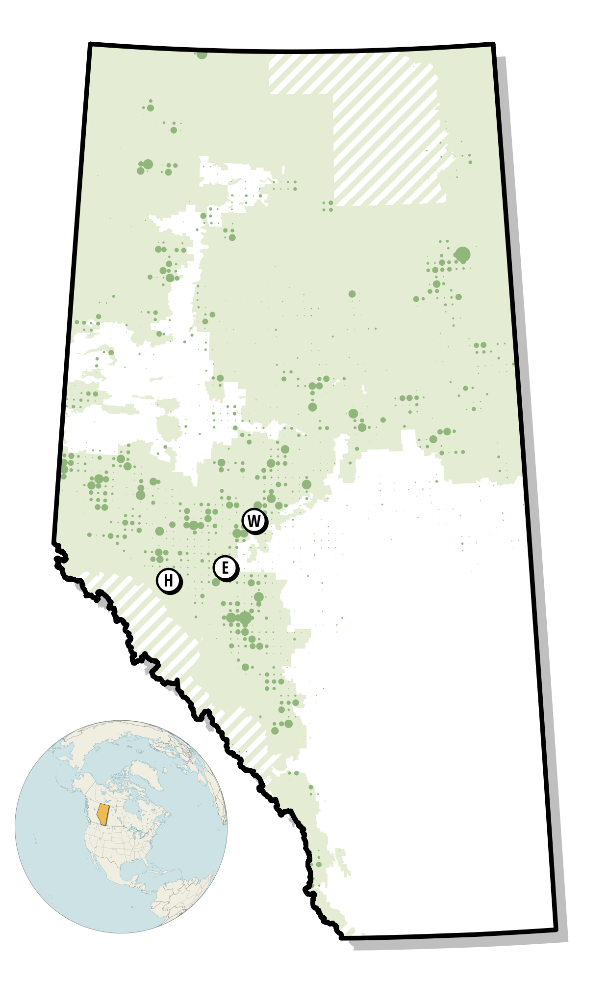

Harvest areas for 2009 with aggregated to township level. Size of circle indicates harvest area in a township in 2009. Harvests are shown relative to Alberta’s Green and White Areas, and those areas not in either (cross-hatching). The locations of Hinton, Edson, and Whitecourt are indicated on the map.

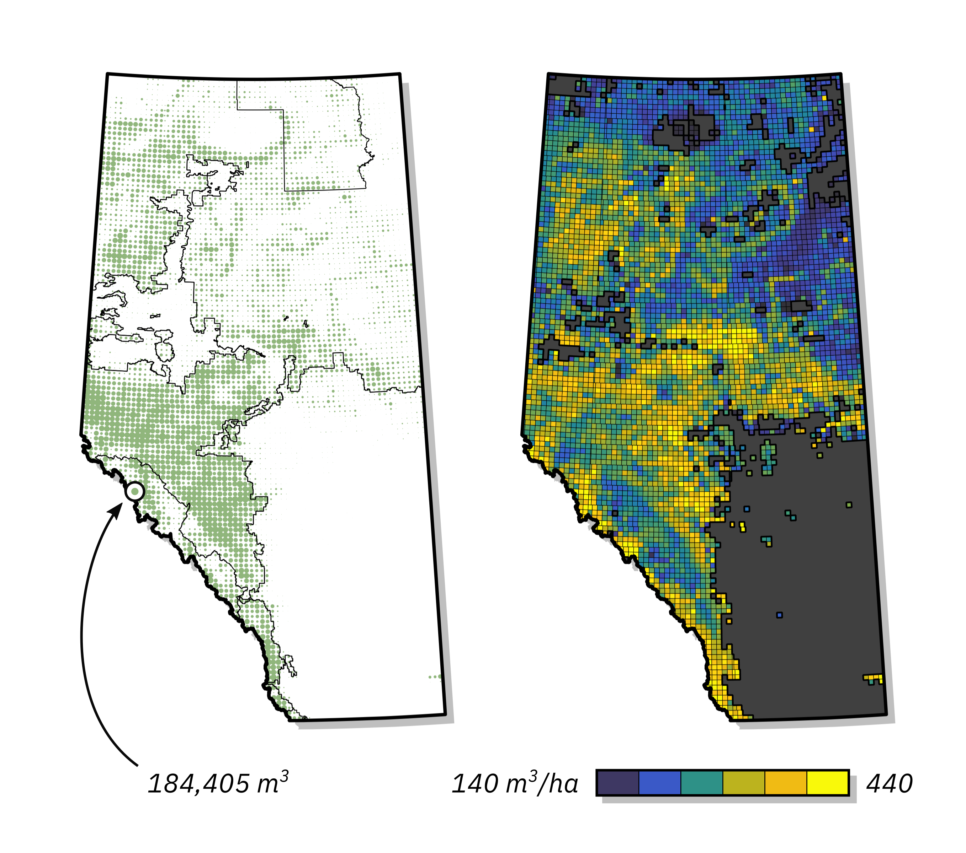

Merchantable volume by township. The left panel indicates total merchantable volume in the township from the 250 m data, and the boundaries of Alberta’s green and white areas.

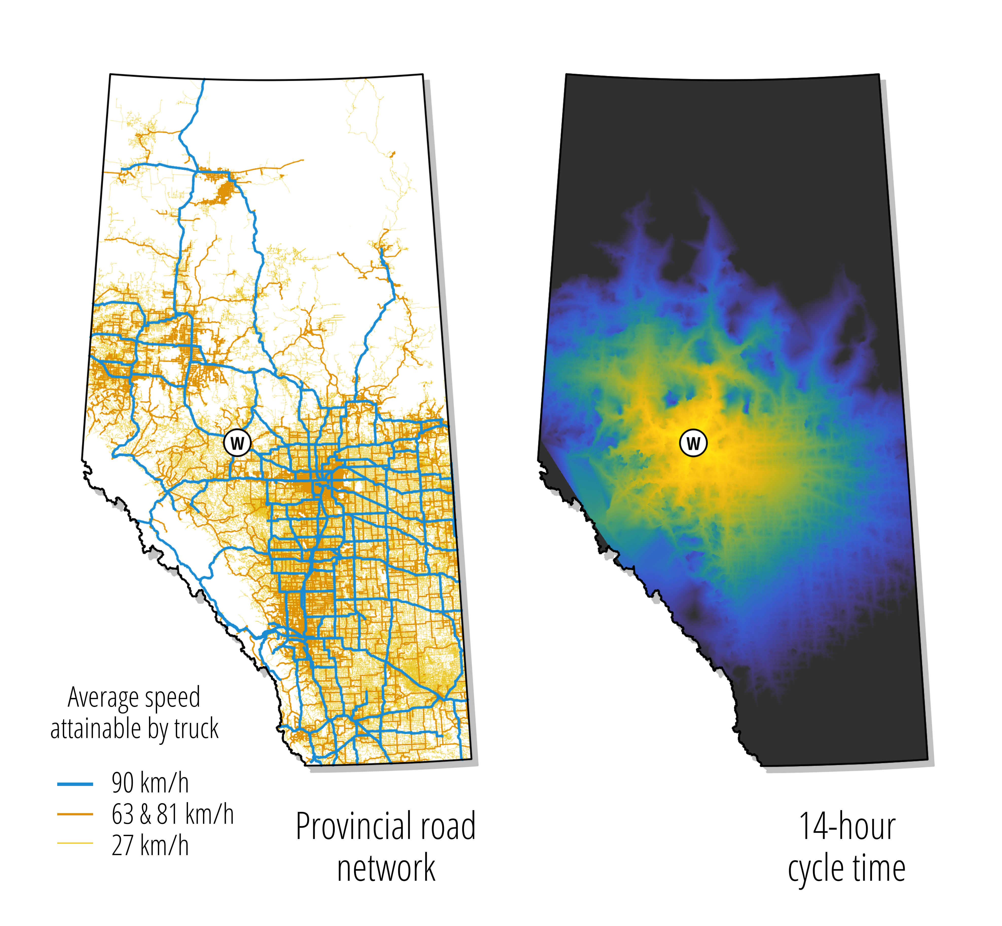

Alberta road network (left) and cycle time (right) from Whitecourt, limited to 13 hours.

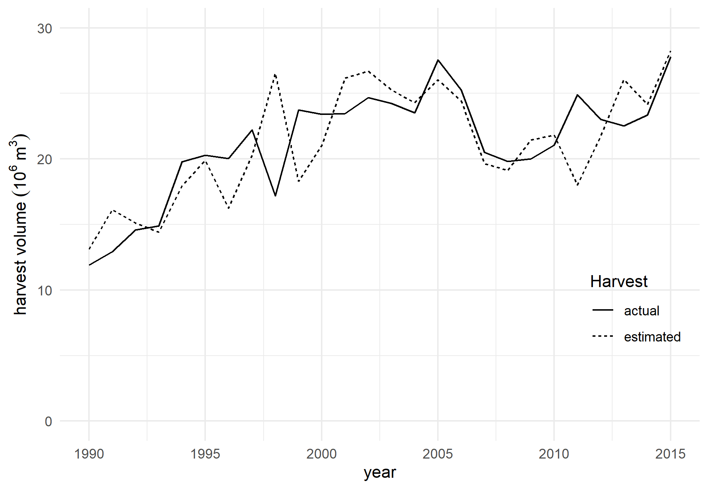

Actual harvest levels from the national forestry database compared with estimated values.

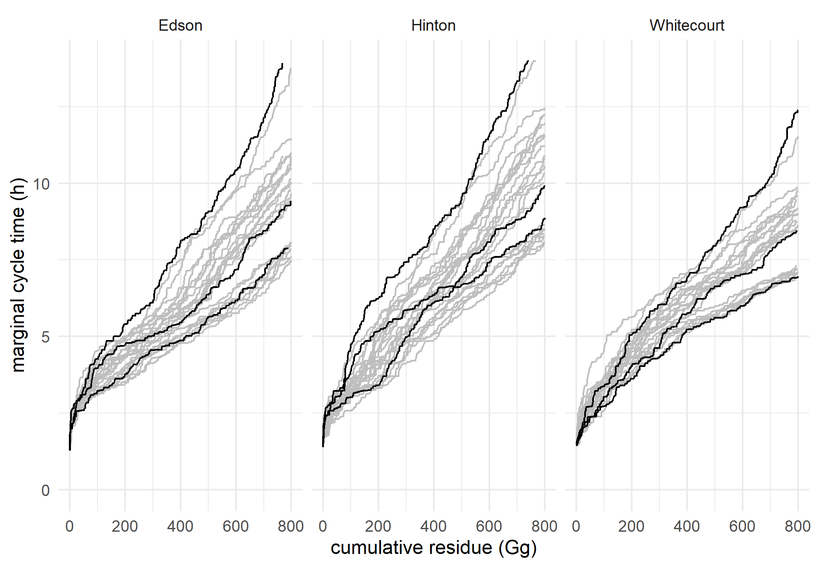

Distribution of cycle times by location for each of the years 1990–2015. Black curves are for a low harvest level year (1990), a medium harvest level year (2009), and a high harvest level year (2005). Gray curves are for each of the other 23 years.

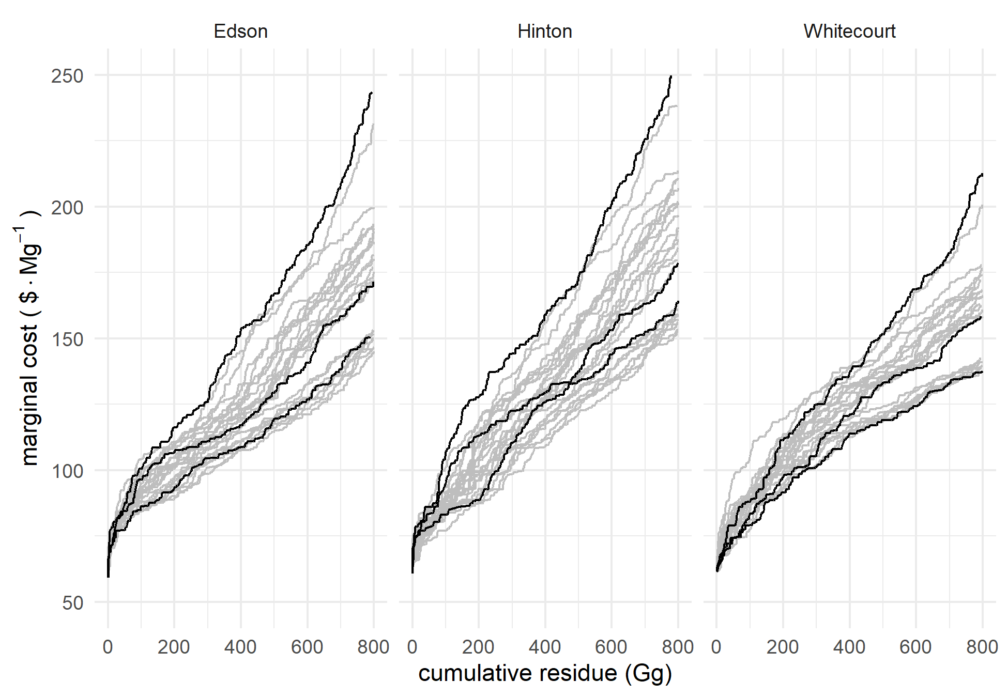

Distribution of marginal costs by location for each of the years 1990–2015. Black curves are for a low harvest level year (1990), a medium harvest level year (2009), and a high harvest level year (2005). Gray curves are for each of the other 23 years.

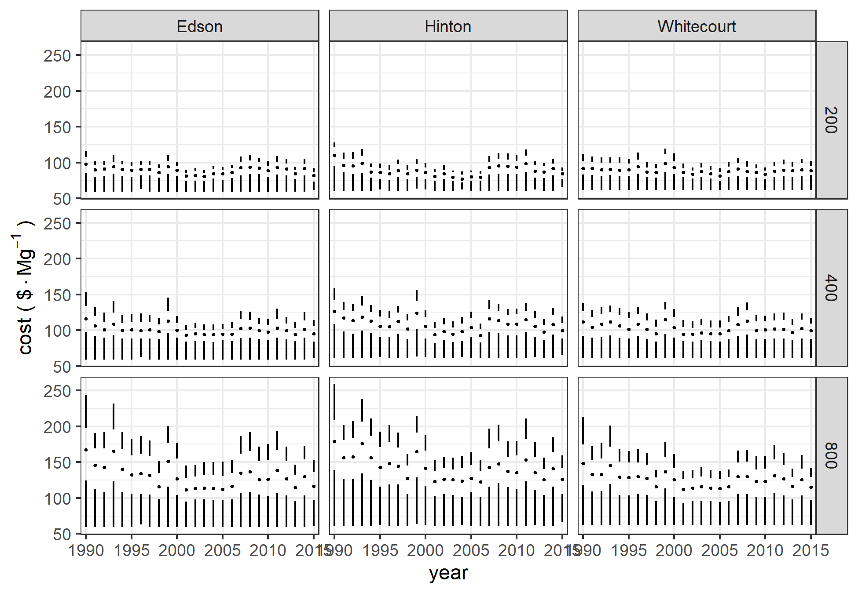

Boxplots of costs by location and biomass requirements for the years 1990–2015.

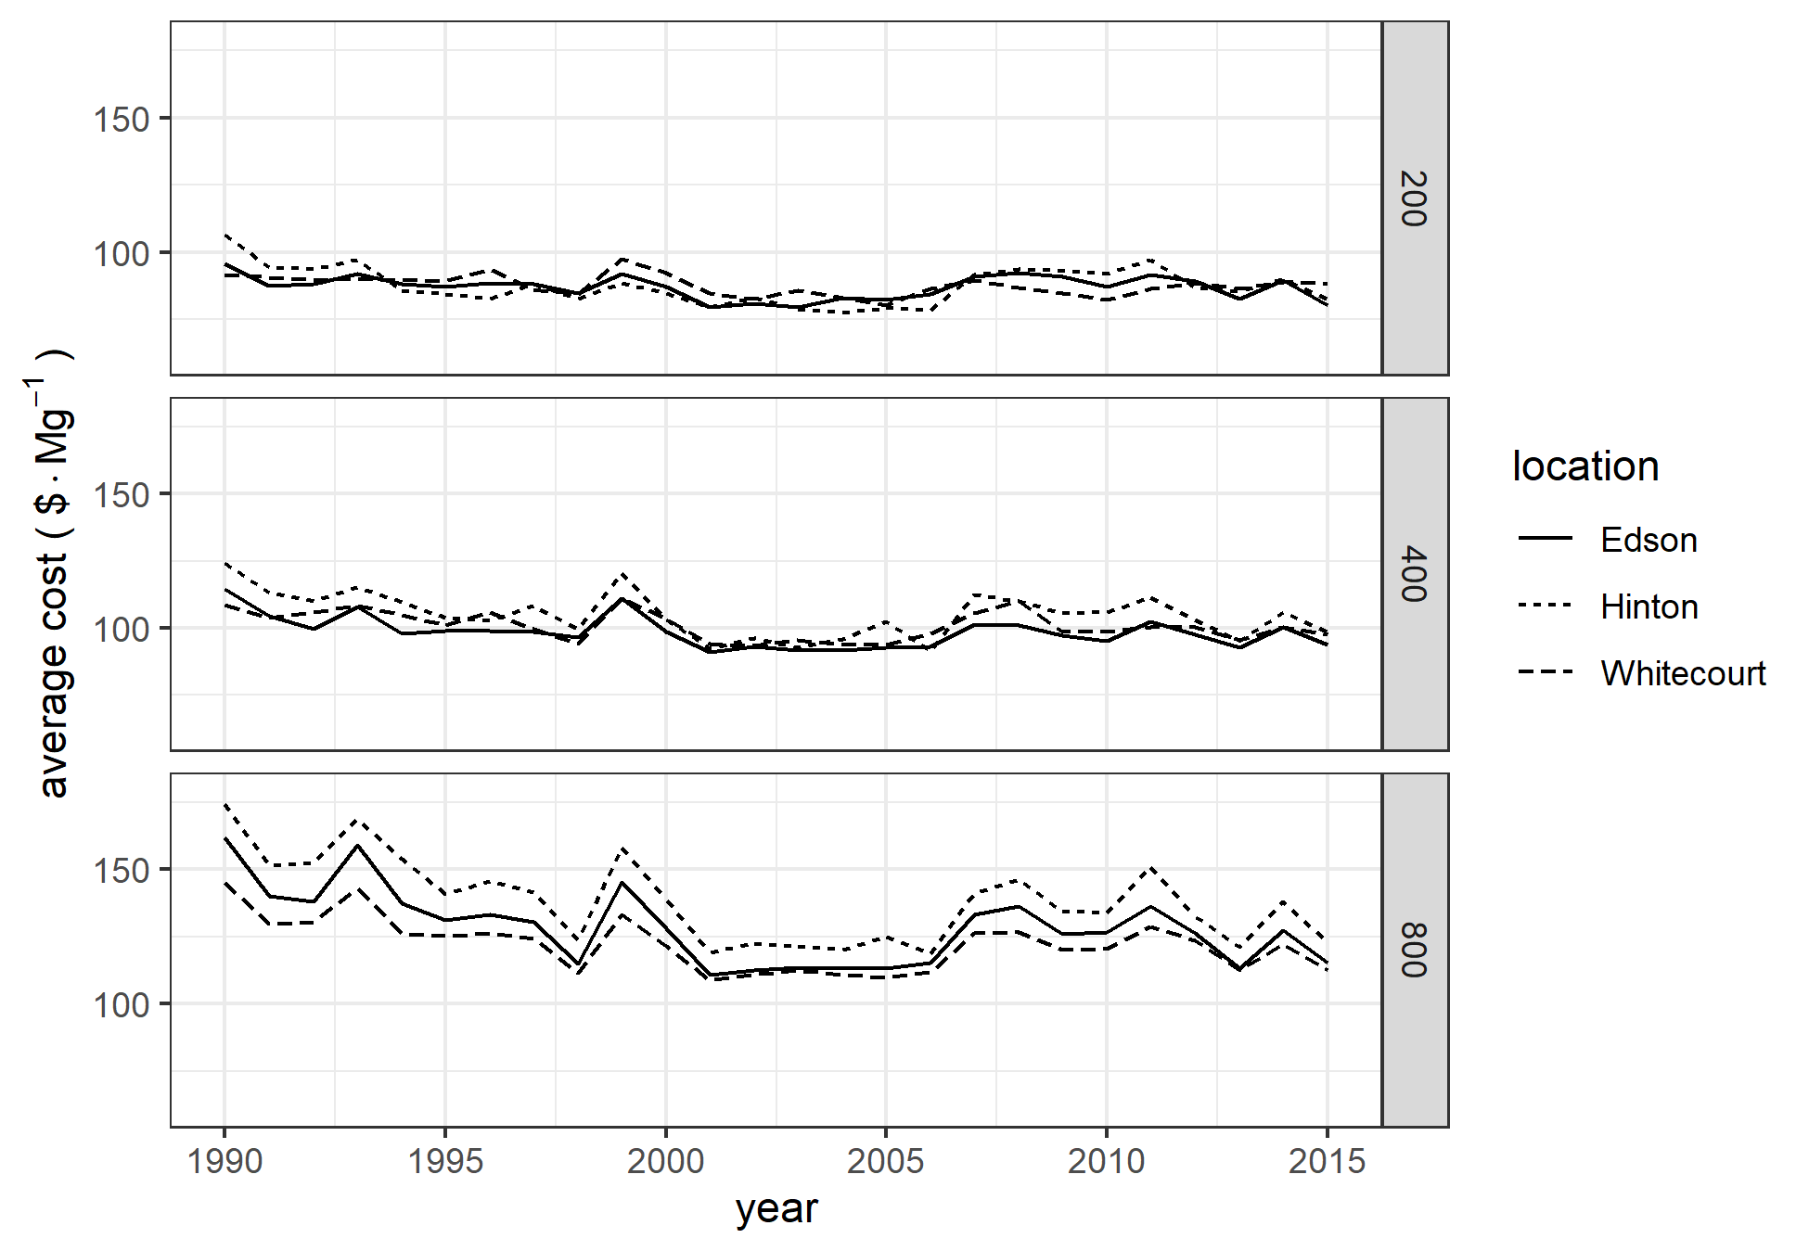

Average costs by location and year.

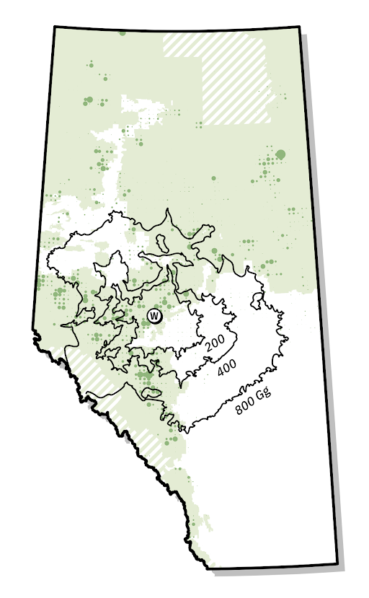

Relationship between timber harvest intensity and required supply area for facilities with biomass requirements of 200, 400, and 800 Gg/a. The area of the dots reflects the proportion of the area of each township harvest in 2009

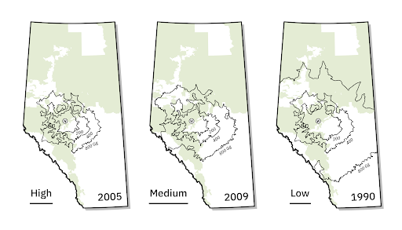

Supply area for facilities in Whitecourt with biomass requirements of 200, 400, and 800 Gg/a for low cost (2005), medium cost (2009), and high cost (1990) years.